Set and their types in Collection:

1. Hash Set
2. Linked Hash Set
3. Tree Set

What is Set?

Set takes care about uniqueness that mean’s set does not allow duplicates.

01]. Hash Set:

1. This is unordered and unsorted set.
2. We use hash code of the object to insert a values.
3. We use Hash Set when Requirement is like “No Need of Duplicates and Dont care about Order.”
4. Hash set does not follow insertion order.
5. In hash Set Duplicates are not allowed.

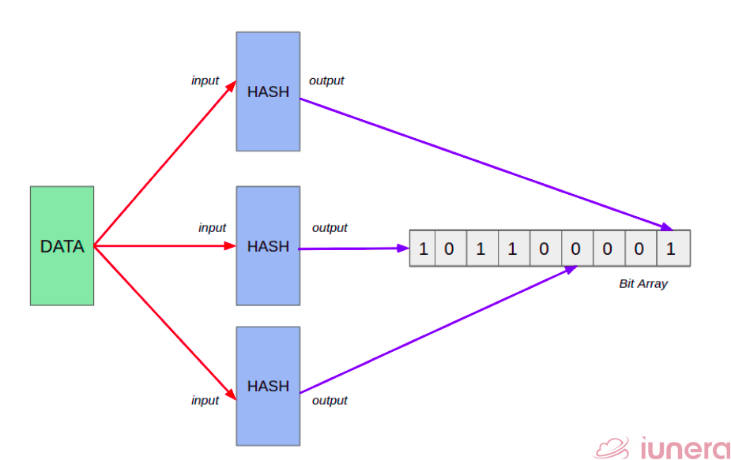

HashSet Example:

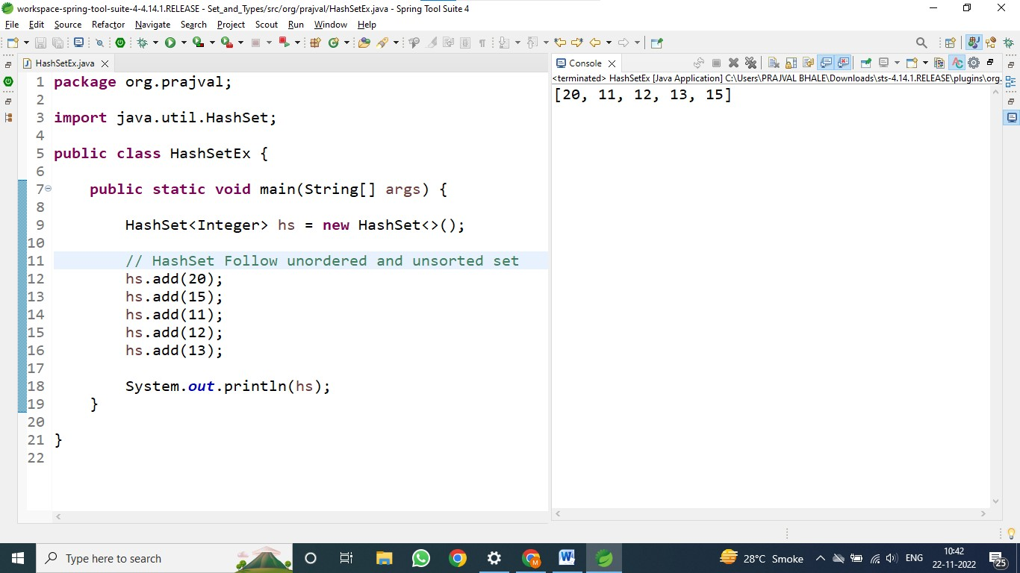

In above screen shot we can see Hash Set Does not follow insertion order and elements are in unsorted order.

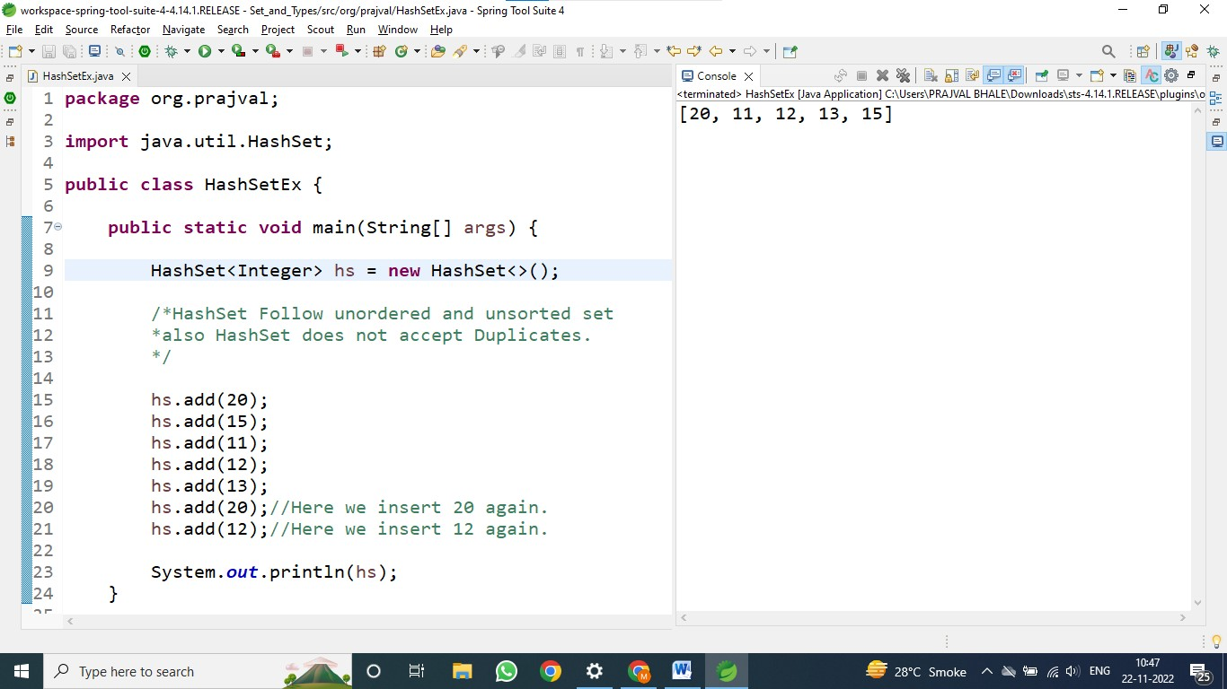

In above screen shot we can see Hash Set Does not allow Duplicate Values.

02]. Linked Hash Set:

1. This is Ordered version of Hash Set.
2. This maintain the Doubly-linked list of all elements.
3. We can use this when iteration order is required.
4. Linked hash set maintain insertion order.
5. In this also Duplicates are not allowed.

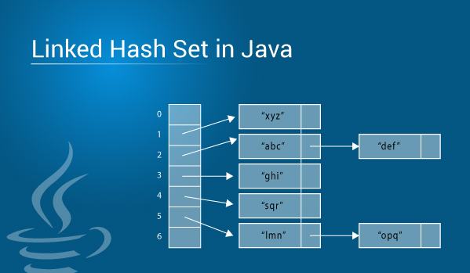

LinkedHashSet Example:

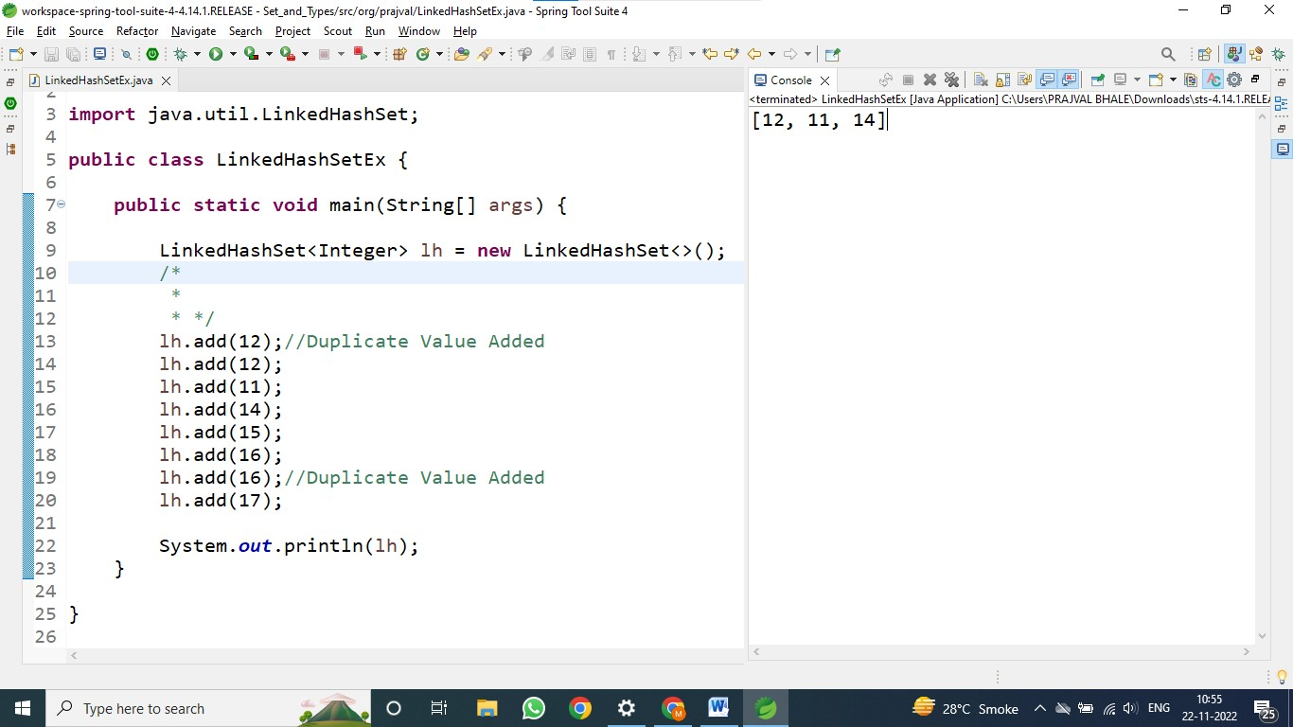

In this above Screen shot we can see Linked Hash Set Does Not Allow Duplicates.

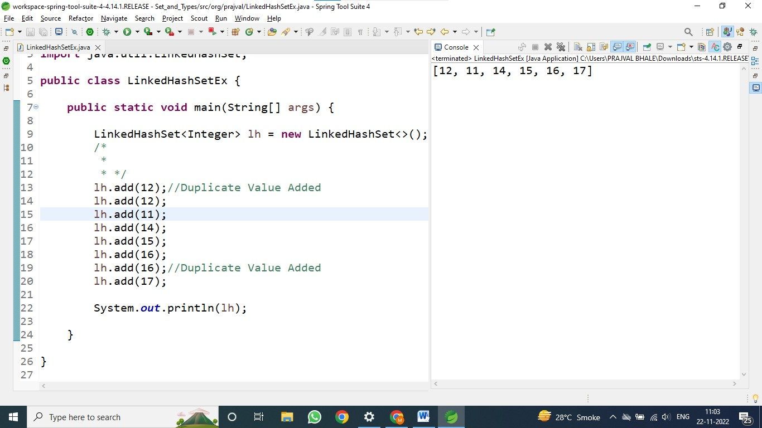

In this above Screen shot we can see Linked Hash Set follows the Insertion order.

03]. Tree Set:

1. Tree set uses the “Read-Black Tree” Structure and Guarantees that the elements will be in ascending order.
2. We can construct this with constructor using comparable or comparator.
3. Tree Set always sort’s the elements in an Ascending order.
4. In tree set duplicate elements are not allowed.

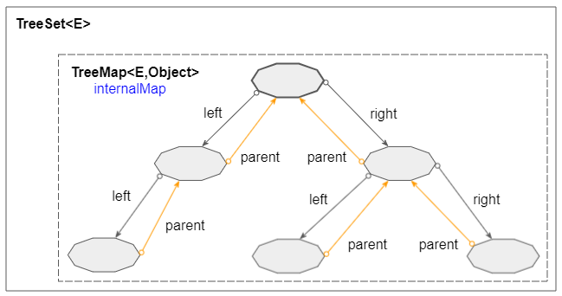

TreeSet Example:

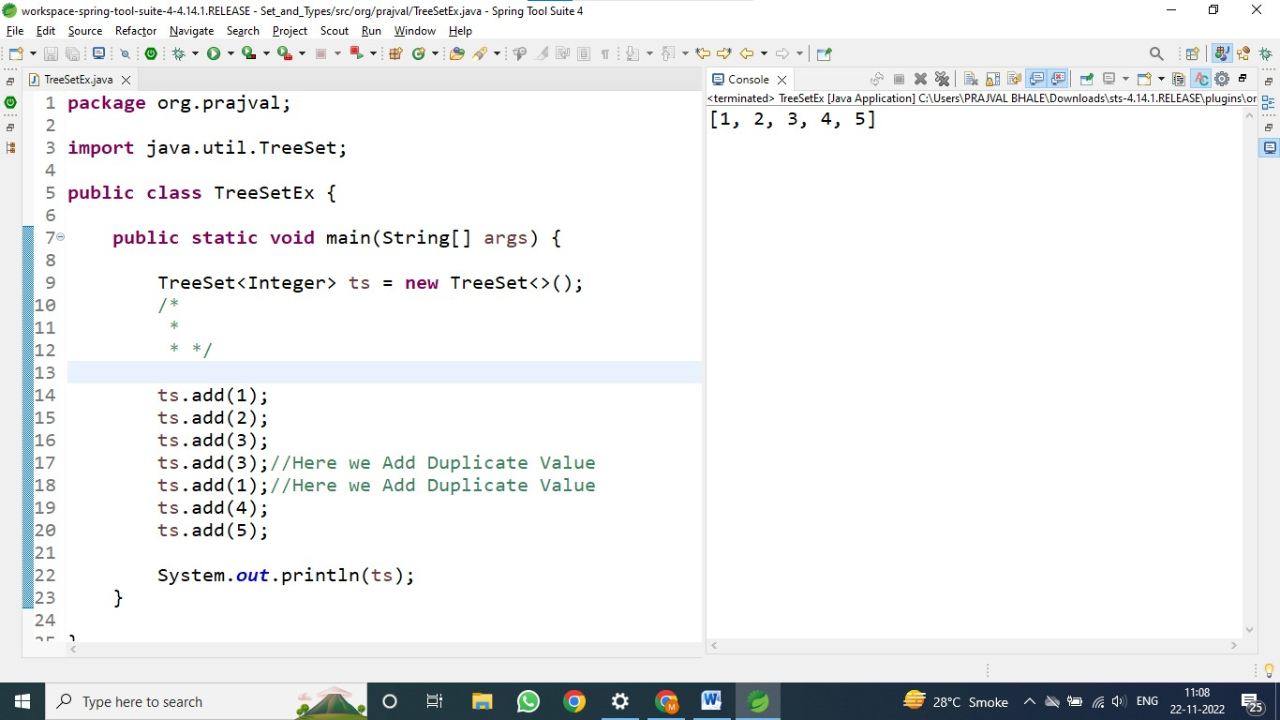

In above screen shot we can see TreeSet does not allow Duplicates.

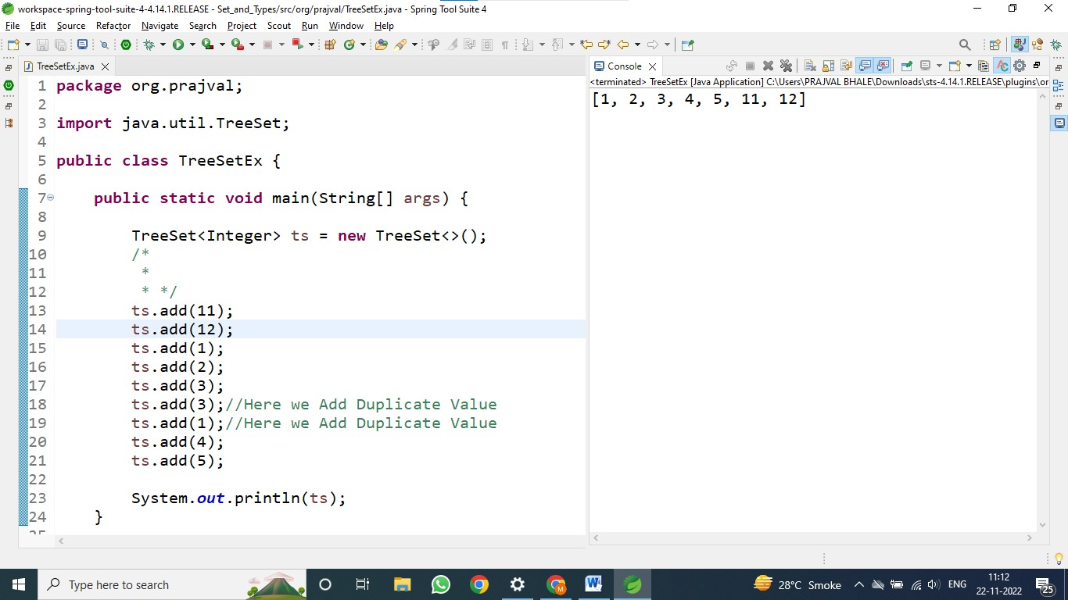

In above screen shot we can see Tree Set does not follow insertion order and Tree Set automatically Sort all element’s.